Brayan Villatoro Lab 1
Submit detailed lab report with screenshots of results, code snippets, and description of what
has been done and observed. Submit any time before Wednesday, Feb. 16, 11:59pm NY time.
Task 1 – Filter Pcap capture to select packets in Python/Scapy
I copied and pasted the existing line of code in “line 8” and modified the file name output into two separate files, titled “IPlayer.pcap” and “otherpackets.pcap”
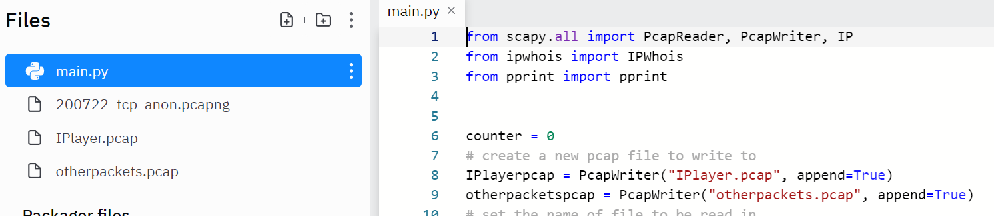
- Lines 12 through 17 puts all packets with IP layers in IPlayerpcap file
- Else command then writes other packets to otherpacketspcap file, we don’t need to clarify contents since the first if statement will remove all packets with IP layers for us and we might not get any packers In the second file since it is possible that there are all the packets have IP layers
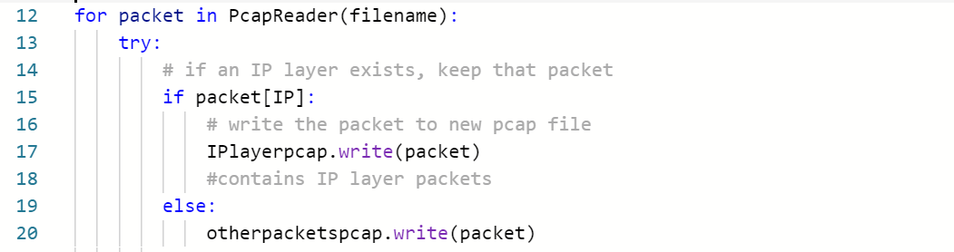

Task 2 – Analysis with Python and tools (IP addresses)
- Within the if statement for packet[IP] I was able to append each packet destination using an array function and the append .dst function. The list output is shown on the right hand side.
- Using pprint(len(IP_dst)) I was able to get the total IP destinations which was a total of 101.
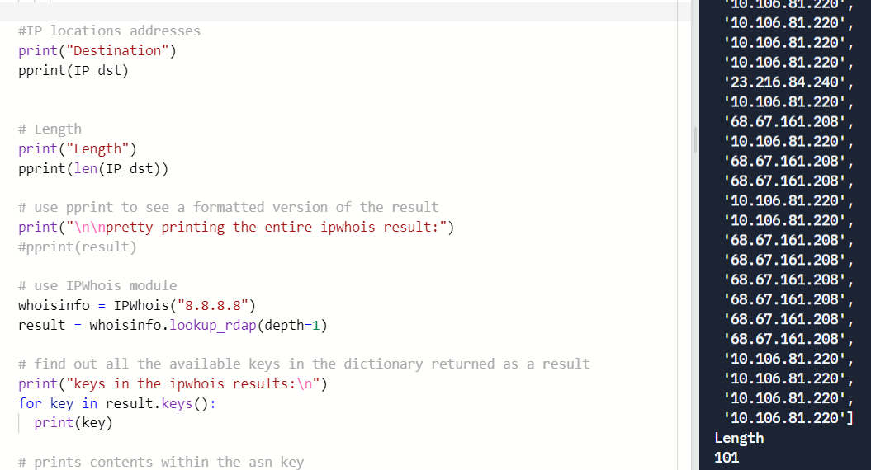
- Using uniqueIP = set (IP_dst), I was able to find the total number of unique IP addresses, the total number was 18, I made sure to use set to eliminate duplicate IP addresses from the list.
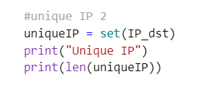

- Using whoisinfo I was able to find out that 1 of the 18 unique IP addresses was from Great Britain and the rest are US based, the date range for the IP addresses spanned from 03-14-2007 to 09-24-2017 being the latest. 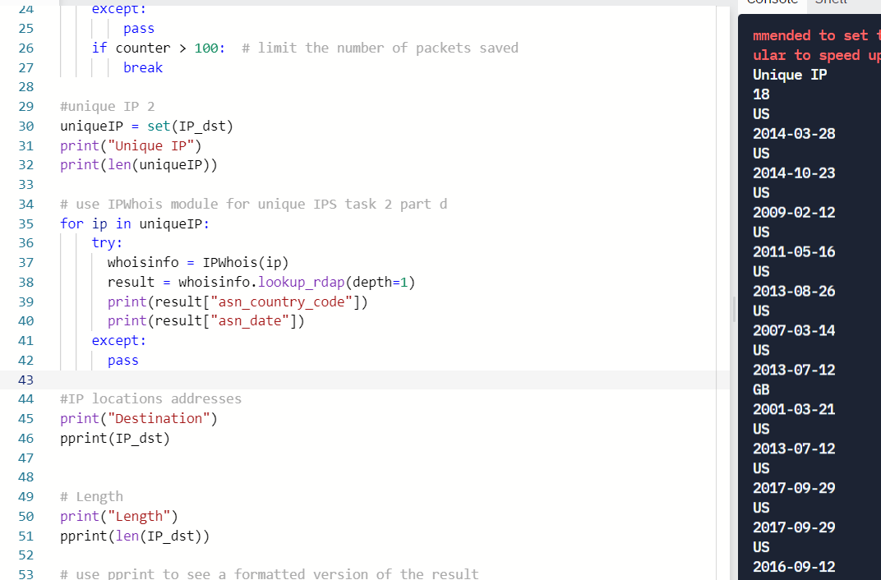

Task 3 – Analysis with Python and tools (other packets)
Nothing exist inside other packets file.

